Here are our current status and questions for Agfa:

* All OVAs are “deployed” as VMs at this point, but are not configured on proper datastores yet. They are all sitting on our temp datastore that is on the “extra unused” disks.
* Windows VMs have been IP’d and renamed appropriately.
* Unix VMs have not been IP’d per the questions below. Once they’re answered, I’ll set IPs and hostnames.
* IPs are in the attached sheet.
* Pending support access to finalize the NAS shares & quotas – the file servers & file systems are up.

General Questions:

* Everything that came from the OLR6U8 OVA has three network interfaces.  Do I just configure an IP on eth0, or do they all need IPs on each interface?  If they only need eth0, can I remove the others from the VM configuration to avoid confusion?
* Similarly, EI_8_TF_7_July_2016, also linux, has two network interfaces, although only eth0 is configured to connect from vsphere.  Can I remove eth1?
* Do windows VMs need to be joined to a domain?  Currently there is no Domain Controller for this VM deployment. For that matter, do the NAS file servers need to be joined to the domain as well?
* I still don’t know where to put the VM configuration files and swap space – see below for details.
* To be clear – I don’t need assistance deploying the OVAs – I need clarification on how the AGFA design spec lines up with the deployed virtual environment.

VM-Specific questions:

This is all related to the lack of direction on storage for VMs.  As has previously been asked to, and confirmed by, AGFA:

“All LUNs should be individually provisioned volumes, provisioned to the vsphere environment, and a VMFS datastore created on each.” - received confirmation from David and his team that we’re spot-on with our understanding of the design spec.

Since no RDMs are in play, all VM data must live on one of those confirmed datastores. As there is not yet a detailed mapping of VM to datastore, here are my observations based on what the deployed VMs actually look like.  As mentioned previously, we can storage vmotion the VM config/swap to one vmfs datastore, and hard drives/vmdks individually to others, but I need to know where.

Additionally, there are 6 defined datastores in the design spec that have no VMs assigned to them – are these perhaps to be used for the config/swap/etc?  If not that – why are they there?

APP Cluster ESXi    VMFS DS Prod App Local - 740GB +12% = 829GB

APP Cluster ESXi    VMFS DS Prod App Rep   - 535GB +12% = 600GB

TEST Cluster ESXi   VMFS DS Test           - 710GB +12% = 796GB

vDP         VMFS DS Backup              - 2775GB +12% = 3108GB

DB Cluster ESXi    VMFS DS Prod DB Local   - 120GB +12% = 135GB

DB Cluster ESXi    VMFS DS Prod DB REP     - 670GB +12% = 751GB

Here are 4 screenshots for the 4 OVAs – everything from the same OVA looks the similar, just with different names.

* OLR6U8 – 36G & 51G hard drives.
  + Need to know where the config goes
  + Need to know where HD1 (36G) goes
  + Need to know where HD2 (51G) goes
  + This OVA comes with a pre-defined memory reservation, which consumes all VM memory at the host level (8GB) and does not require swap space.

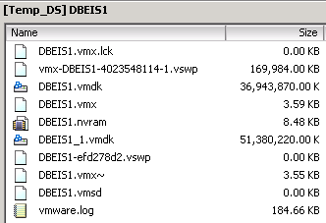

* WIN2012R2_03_may_2017 – 100GB HD
  + Need to know where the config/swap goes
  + Need to know where HD1 (100GB) goes
  + This OVA does not have a memory reservation, so vswp space per configured virtual memory (currently 4GB) is required – this must be in the same place as the config.

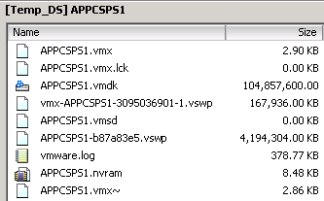

* EnterpriseImagingBI_v810 – 100GB HD
  + Need to know where the config/swap goes
  + Need to know where HD1 (100GB) goes
  + Note the C:\ drive is configured for a 60GB partition at the guest OS level, with 40GB free space
  + This OVA does not have a memory reservation, so vswp space per configured virtual memory (currently 8GB) VM is required – this must be in the same place as the config.

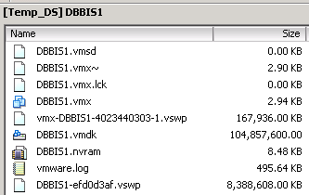

* EI_8_TF_7_July_2016 – 600GB, 20GB, 50GB, 200GB, 60GB
  + Need to know where config goes
  + Need to know where 5 HDs go
  + This OVA comes with a pre-defined memory reservation, which consumes all VM memory at the host level (currently 8GB) and does not require swap space.

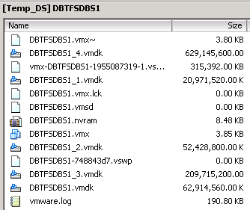

* DBEIS1
  + OLR6U8 source
  + The design spec has 8 assigned datastores – On pool1 – 451GB, 388GB, 191GB, 11GB, 4GB, 9GB, 9GB and on pool3 – 3179GB
  + The deployed OVA has 2 hard drives, 35G and 49G, which don’t match up to any of the sizes of the assigned volumes.
  + There is no obvious direction on how to configure this VM’s vmdk or config storage
* DBTXDBS1
  + OLR6U8 source
  + The design spec has 2 assigned datastores – 112GB on Pool3, 56GB on pool7
  + The deployed OVA has 35G and 49G hard drives.
  + Does config & 35GB HD1 go on pool3, and 49GB HD2 on pool7?
* APPTXS1
  + OLR6U8 source
  + The design spec has 1 assigned datastore – 168GB on pool4
  + The deployed OVA has 35G and 49G hard drives
  + Does all VM data – config/HD1/HD2 go on the single datastore?
* DBBIS1
  + EnterpriseImagingBI_v810 source
  + The design spec has 2 assigned datastores – 34GB on pool3 and 227GB on pool7
  + The deployed OVA has 1 100GB hard drives
  + There is no obvious direction on how to configure this VM’s vmdk, config, or swap storage
* DBTFSDBS1
  + EI_8_TF_7_July_2016 source
  + The design spec has 3 assigned datastores – 1260GB on Pool3, 2028GB on pool4, and 420GB on pool7
  + The deployed OVA has 5 HDs – HD1 (60GB), HD2 (20GB), HD3 (50GB), HD4 (200GB) and HD5 (600GB)
  + There is no obvious direction on how to configure this VM’s vmdk or config storage
* APPCSPS1
  + WIN2012R2_03_may_2017 source
  + The design spec has 0 assigned datastores
  + The deployed OVA has 1 100GB HD1
  + There is no obvious direction on how to configure this VM’s vmdk, config, or swap storage
* APPCSPS2
  + WIN2012R2_03_may_2017 source
  + The design spec has 0 assigned datastores
  + The deployed OVA has 1 100GB HD1
  + There is no obvious direction on how to configure this VM’s vmdk, config, or swap storage
* APPCWPS1
  + OLR6U8 source
  + The design spec has 0 assigned datastores
  + The deployed OVA has 35G and 49G hard drives
  + There is no obvious direction on how to configure this VM’s vmdk or config storage
* APPCWPS2
  + OLR6U8 source
  + The design spec has 0 assigned datastores
  + The deployed OVA has 35G and 49G hard drives
  + There is no obvious direction on how to configure this VM’s vmdk or config storage
* APPLB1
  + OLR6U8 source
  + The design spec has 0 assigned datastores
  + The deployed OVA has 35G and 49G hard drives
  + There is no obvious direction on how to configure this VM’s vmdk or config storage
* GTIS1
  + OLR6U8 source
  + The design spec has 0 assigned datastores
  + The deployed OVA has 35G and 49G hard drives
  + There is no obvious direction on how to configure this VM’s vmdk or config storage
* APPCONS1
  + OLR6U8 source
  + The design spec has 1 assigned datastore, 112GB on pool2
  + The deployed OVA has 35G and 49G hard drives
  + Does all VM data – config/HD1/HD2 go on the single datastore?
* APPADMNS1
  + WIN2012R2_03_may_2017 source
  + The design spec has 1 assigned datastore, 1147GB on pool3
  + The deployed OVA has 1 100GB HD1
  + As there is such a size difference, there is no obvious direction on how to configure this VM’s vmdk, config, or swap storage
* APPHPDBS1
  + OLR6U8 source
  + The design spec has 2 assigned datastores, 560GB on Pool3 and 560GB on Pool7
  + The deployed OVA has 35G and 49G hard drives
  + There is no obvious direction on how to configure this VM’s vmdk or config storage
* APPHPAPS1
  + OLR6U8 source
  + The design spec has 0 assigned datastores
  + The deployed OVA has 35G and 49G hard drives
  + There is no obvious direction on how to configure this VM’s vmdk or config storage
* APPSP
  + WIN2012R2_03_may_2017 source
  + The design spec has 0 assigned datastores
  + The deployed OVA has 1 100GB HD1
  + There is no obvious direction on how to configure this VM’s vmdk, config, or swap storage
* ADMINAMF
  + OLR6U8 source
  + The design spec has 0 assigned datastores
  + The deployed OVA has 35G and 49G hard drives
  + There is no obvious direction on how to configure this VM’s vmdk or config storage
* TESTEIDB
  + OLR6U8 source
  + The design spec has 2 assigned datastores, 168GB on Pool3 and 168GB on Pool7
  + The deployed OVA has 35G and 49G hard drives
  + There is no obvious direction on how to configure this VM’s vmdk or config storage
* TESTTXS1
  + OLR6U8 source
  + The design spec has 0 assigned datastores
  + The deployed OVA has 35G and 49G hard drives
  + There is no obvious direction on how to configure this VM’s vmdk or config storage
* TESTCSPS1
  + WIN2012R2_03_may_2017 source
  + The design spec has 2 assigned datastores, both 500GB on Pool4
  + The deployed OVA has 1 100GB HD1
  + There is no obvious direction on how to configure this VM’s vmdk, config, or swap storage
* TESTCWPS1
  + OLR6U8 source
  + The design spec has 1 assigned datastore – 224GB on pool4
  + The deployed OVA has 35G and 49G hard drives
  + Does all VM data – config/HD1/HD2 go on the single datastore?
* TESTCONS1
  + OLR6U8 source
  + The design spec has 2 assigned datastore – 336GB on pool3 and 112GB on pool4
  + The deployed OVA has 35G and 49G hard drives
  + There is no obvious direction on how to configure this VM’s vmdk or config storage